# Visual Inspection

Check presence and polarity of the elements on the top side.

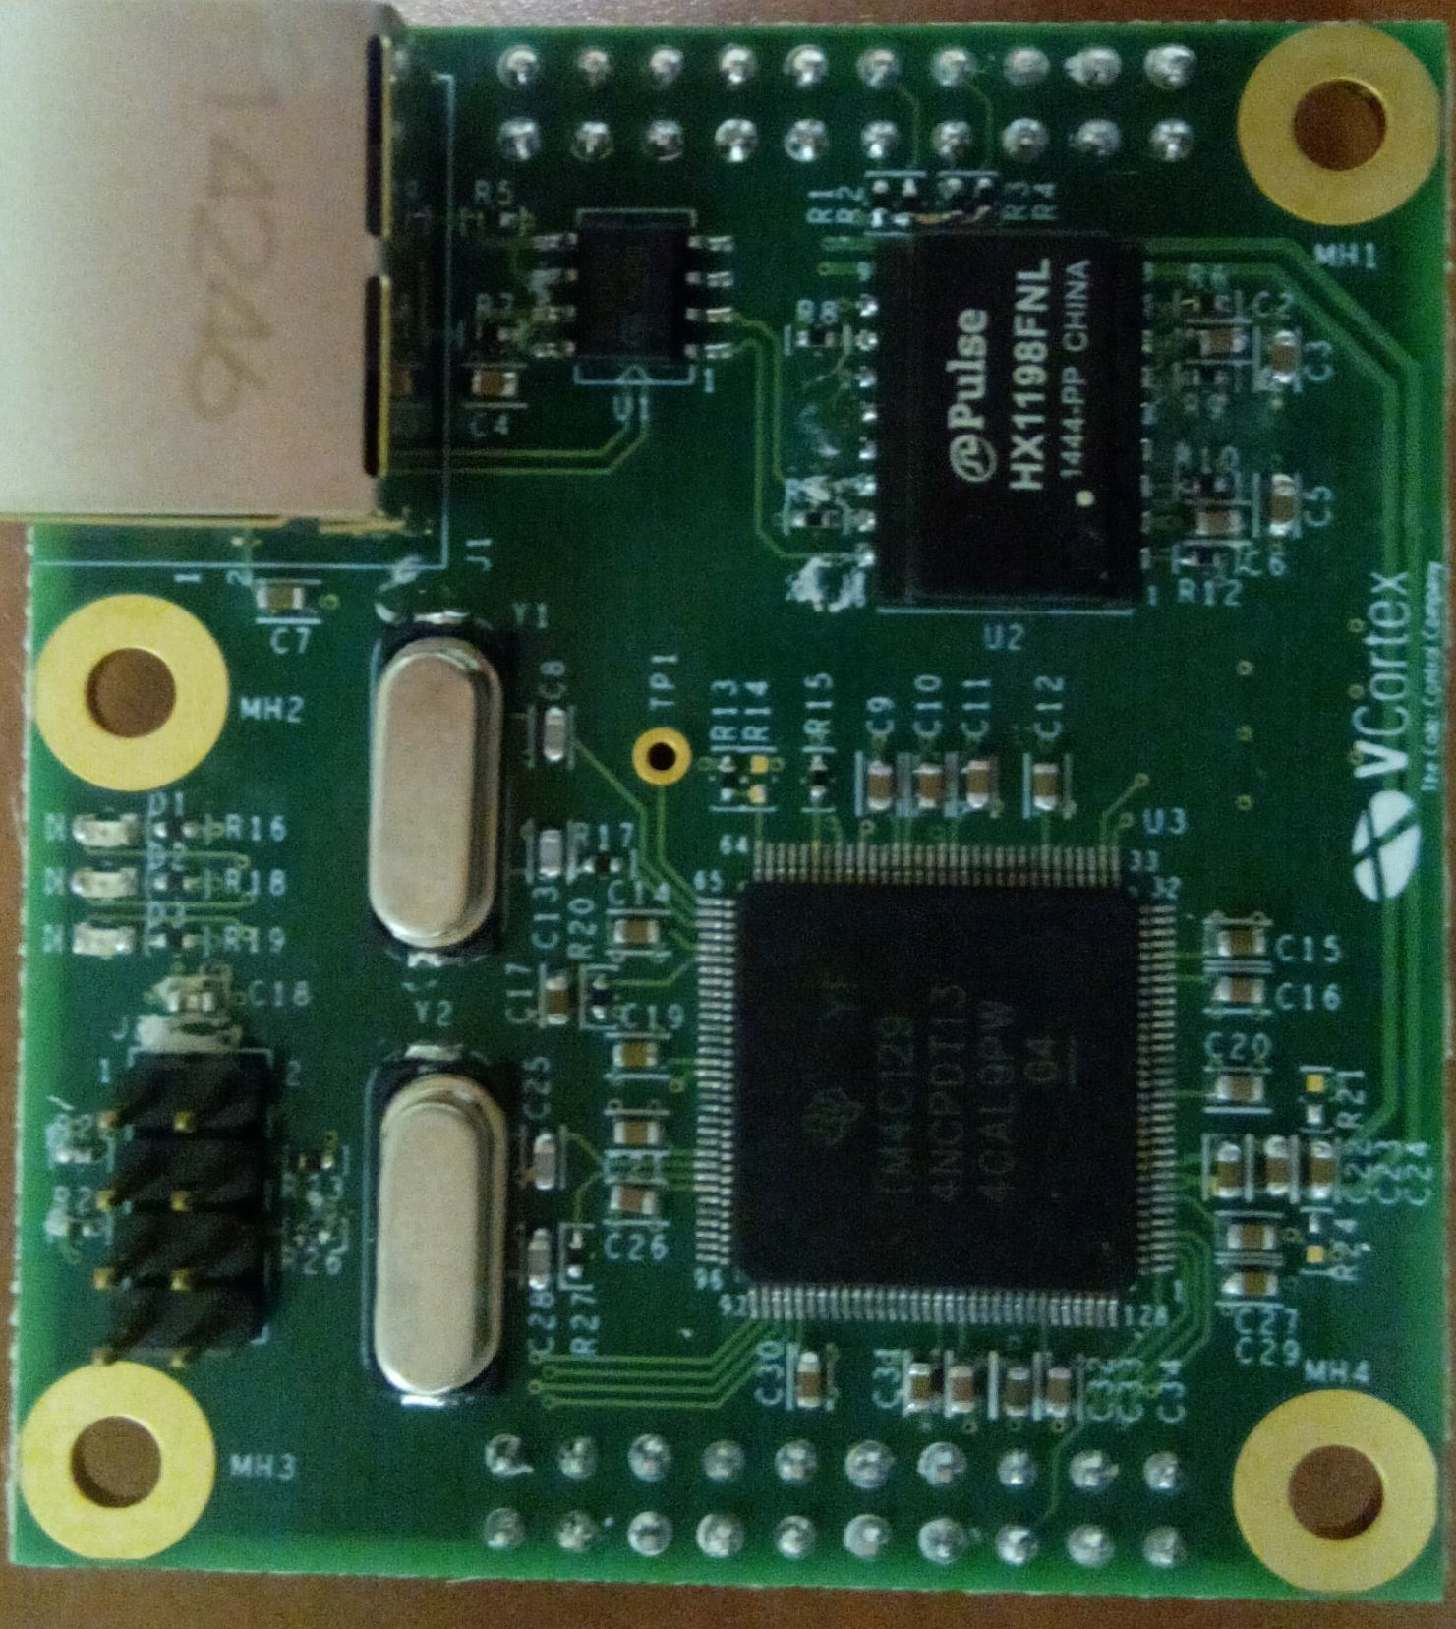

# Electrical verification

|  |  |  |  |  |
| --- | --- | --- | --- | --- |
|  | Action | Expected Results | Actual results | Pass/Fail |
| 1 | Burning the flash:  Connect the burning tool to J2 of the board, and load the proper BIN file with LM Flash Programmer tool. | Note that led D1 is flashing in a rate of 2 flashes a second. |  |  |
| 2 | Connect the board to a PC through the Ethernet connector J1 (note: the burning tool should still be connected for power supply). | Note that led D2 turns on when the plug is inserted. |  |  |
| 3 | Start a CMD window on the PC. ran “ping 10.0.0.131 –t” to send ping commands recursively | Note that led D3 is blinking. Note that ping time is less than 3mSec and no ping failures are listed. |  |  |
| 4 | Start internet browser. Write 10.0.0.131 on the address bar | Note that the ETHIIC-1 first page is displayed. |  |  |